**Amplitude Detector and phase corrector**

This document gives the details of 3 phase amplitude detector and phase corrector. Block diagram of the design system is given in Fig. 1.

The system receive R-Y-B phase and 12V , 5V& Gnd inputs. RYB phase is used to detect amplitude of R-B, Y-B and Y-R lines. R-B and Y-B are also used for phase detection of R/Y/B lines. 12 V and 5V power is used as logic supply.

Star Control

R

System Block diagram

Star Control

Star Control

Y

B

Star Control

5V

Star Control

12V

GND

Star Control

Fig.1 Amplitude Detection and Phase Correction Block Diagram

More conceptual details of the system is given in Fig. 2. The R-Y, Y-B and Y-R inputs are connected to a precision optocoupler. Based on the amplitude of the signal, it will give the optocoupled output The peak of this output is delectated by a peak detector circuit. Output of the peak detector is given to the ESP32 controller for further processing. As each peak detector provides two optocoupled output, the second output of optocouplers, which are connected to R-Y and Y-B are given to a phase detector. This will detect the phase of R-B w.r.t. Y-B signals. The phase detected output is coupled to the ESP32, which will make appropriate decision whether to select normal phase relays or Reverse mode relays.

R

Y

B

B

R

Amplitude Detector

Amplitude Detector

Amplitude Detector

optocoupler

optocoupler

optocoupler

Star Control

ESP32

Delta Control

Y

B- Control

Reverse Control

Normal Control

Phase Detector

Fig.2 Amplitude and Phase detection

Each output for relay is provided with protection circuit so that two conflicting relays are not selected at the same time. Block Schematic is shown in Fig. 3.

Circuit for Amplitude and phase detection is shown in Fig.4. Protection circuit along with the relay driver is given in Fig. 5.

Detailed circuit diagram is given in Fig. 6.

Driver

Protection Circuit

Star

ESP32

B- Control

Reverse Control

Normal Control

Delta Control

Star Control

OR

Driver

Driver

Driver

Driver

Reverse

Normal

Protection Circuit

Delta

Fig. 3 Protection Blocks

**3-Phase Corrector and Protection Circuit**

A 3-phase corrector and protection circuit is designed to ensure the proper operation of three-phase systems by detecting faults, monitoring phase alignment, and making real-time adjustments or corrections. This system is crucial for the protection of electrical equipment such as motors, transformers, and industrial machinery, ensuring they operate within their specified parameters.

**Concept Overview:**

In the context of your described system, the circuit utilizes optocouplers, peak detectors, and a phase detector, along with an ESP32 microcontroller to control and monitor the operation of the system. The primary function of this circuit is to:

1. **Detect Phase Alignment and Amplitude**: The system uses inputs labeled R-Y (Red-Yellow), Y-B (Yellow-Blue), and Y-R (Yellow-Red), which are connected to a precision optocoupler.
2. **Monitor Signal Amplitude**: The optocoupler detects the amplitude of the input signals. Based on the input signal's amplitude, the optocoupler provides an output that is sent to a peak detector.
3. **Detect Signal Peaks**: The peak detector captures the peak of the optocoupled output, which indicates the maximum amplitude of the input signal. The output of the peak detector is sent to the **ESP32 microcontroller** for further processing.
4. **Phase Detection**: Since each peak detector provides two optocoupler outputs, the second output is connected to the phase detector. The phase detector compares the phase difference between the R-B and Y-B signals, ensuring that the system operates in the correct phase sequence.

**System Components:**

1. **Optocouplers**: Optocouplers are used for isolating different parts of the circuit while transferring the signal. The optocoupler ensures that high-voltage signals do not directly affect the low-voltage logic system (ESP32).
   * **R-Y, Y-B, Y-R Inputs**: These represent the three-phase inputs (Red-Yellow, Yellow-Blue, and Yellow-Red phases). The optocouplers monitor these signals for amplitude and provide isolation between the high-voltage signals and the controller.
2. **Peak Detector Circuit**: A peak detector captures the peak value of the optocoupler's output. It consists of a diode, capacitor, and resistor. When the optocoupler output rises, the capacitor charges to the peak voltage, and the voltage across the capacitor represents the peak signal value. This is then sent to the ESP32 for further processing.
   * **Purpose**: The peak detector ensures that the ESP32 gets accurate information about the signal's maximum value, which is crucial for detecting abnormalities or inconsistencies in the input signals.
3. **Phase Detector**: The phase detector is responsible for measuring the phase difference between the R-B and Y-B signals. It compares these two signals to determine if the phase sequence is correct or if there is a phase fault, such as a phase loss or reversal.
   * **Operation**: The phase detector generates a voltage that is proportional to the phase difference. This output is then sent to the ESP32, which uses it to make decisions about the relay mode.
4. **ESP32 Controller**: The ESP32 is the central processing unit of the system, responsible for collecting data from the peak detector and phase detector, processing the signals, and controlling the relays.
   * **Decision Making**: Based on the phase detection output, the ESP32 determines whether the system is operating with the correct phase sequence. If the sequence is correct, it triggers the normal-phase relays. If the phase sequence is reversed or abnormal, the ESP32 activates reverse-mode relays to prevent damage to the connected equipment, such as motors.

**Working of the System:**

1. **Signal Input**: The system receives three-phase signals, which represent the different phases (R-Y, Y-B, and Y-R). These are input to the optocouplers, which isolate the high-voltage signals and convert them to low-voltage signals for further processing.
2. **Signal Amplitude Detection**: The optocouplers transmit the signals to the peak detector circuits. The peak detector captures the maximum signal amplitude and sends this information to the ESP32 for analysis.
3. **Phase Detection**: The second output of the optocouplers (connected to the R-Y and Y-B inputs) is given to the phase detector. The phase detector compares the phase difference between R-B and Y-B to identify the phase sequence.
4. **Phase Correction Decision**: If the phase sequence is correct (R-Y-B), the ESP32 will allow the normal-phase relay to be activated. If the sequence is reversed (e.g., B-Y-R), the ESP32 will trigger the reverse-mode relay, ensuring that the load is connected with the correct phase alignment.
5. **Relay Activation**: Depending on the decision made by the ESP32, the relays are activated to either connect the load with the normal-phase sequence or reverse the phase sequence as necessary. This provides protection against phase issues such as phase loss or incorrect phase sequence.

**Protection Mechanisms:**

The system provides protection for the following scenarios:

1. **Phase Loss**: If one of the phases is missing or outside the acceptable limits, the phase detector will detect this, and the ESP32 can shut down the system or activate an alarm to prevent damage to the equipment.
2. **Phase Reversal**: If the phase sequence is reversed (e.g., Y-R-B instead of R-Y-B), the phase detector will detect this, and the ESP32 will activate the reverse-mode relays to prevent equipment damage.
3. **Signal Integrity**: By monitoring the peak signal values, the system ensures that the signals are within acceptable amplitude ranges, providing additional protection against under-voltage or over-voltage conditions.



Fig.4 Protection and Driver circuit

[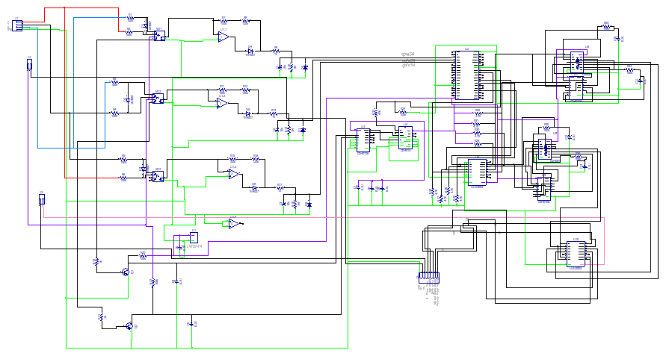](https://drive.google.com/file/d/1nWXTwJsrF3SBVHt6xdAprLbQePqdb-S8/view?usp=sharing)

Fig.5 Detailed Circuit Diagram

**Conclusion:**

The 3-phase corrector and protection circuit is designed to provide real-time phase monitoring and correction, ensuring the safe operation of connected equipment in a three-phase electrical system. By using optocouplers, peak detectors, and a phase detector, the system can automatically detect and correct phase mismatches, protecting motors and other machinery from damage due to phase errors. The ESP32 controller plays a crucial role in processing the signals and making decisions regarding relay control, ensuring the system operates efficiently and safely.